Jamie’s Painting & Design Art Class
Grades K-3

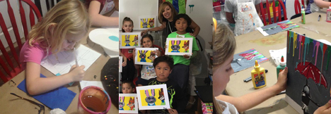

Description: Pablo Picasso said, “Every child is an artist. The problem is how to remain an artist once he/she grows up.” ~ Pablo Picasso
Children love to be creative and make art, the problem is that they need to be introduced to many different art mediums to figure out which one they like or, better yet, love. All of my students are encouraged to not only learn about a famous, or not so famous, artist; they are encouraged to try many different mediums. Each week we will learn about a new artist and a new technique. Your children will be taught “art tricks” or “special ways” to make their art the best it can be.
Learning about a different artist, a sculptor, an architect or a movement is not only important but inspirational for the children. All of the artists will come from different countries, centuries and of course styles and movements.
I believe that there are no accidents in art……only happy mistakes. Everyone’s art is unique and is never wrong. I will make sure the children work at their own pace and are able to continue to improve throughout the project. Whether they use sharpie markers, add glitter, sequins, or just continue to paint…...the end result is a beautiful art project made by your amazing children.
Jamie Risdon Lentzner is an art teacher with a Computer Arts Degree from SJSU. She has been teaching art since her son was born in 1999 when she left the Children’s Educational Software industry. After her daughter was born in 2002 she started her own business making children’s ceramic wall art. Her art was sold in catalogs, online and in stores all over the United States. In 2014 she switched gears and decided to teach full time and closed the manufacturing side of her business. Jamie teaches art for Visions, Horizons & in her own private art studio. Jamie lives with her husband and two teenage children in El Dorado Hills.
As much as Jamie loves teaching she always wants to teach something original, so she refuses to ever teach the same art project more than once.
Class Fee: $169 Enrollment: 6-20 students

