Beginner Music Mind Games
Grades K-3, Wednesdays 10:15-11:15 a.m. 2017-18
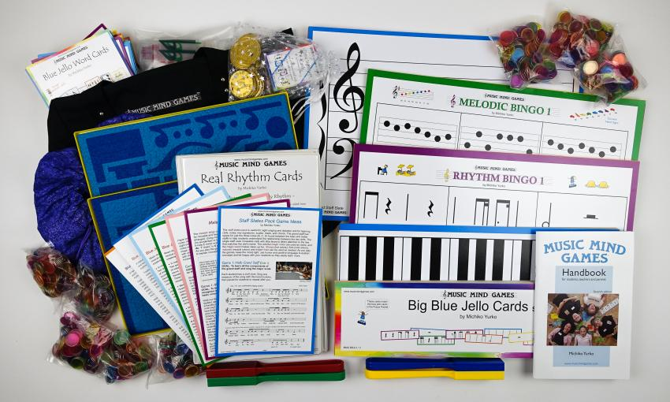

Description: Learning to read music is like learning to read a language of the earth, a language loved and enjoyed by peoples of all lands. Music is constantly being created, takes many forms and can be molded to take on its own unique appeal to various cultures. Behind these glorious sounds of music is a magnificent system of written music. With western music, this system enables the reader to interpret the exact pitch, rhythmic duration, tempo, emotion and loudness or softness of a series of notes. All of this comes to life through the composer’s use of a highly systemized series of dots, lines, symbols and words. It is a language which has evolved over countless centuries and is delicately expressive yet as sturdy as any mathematical equation.
In Music Mind Games we learn at an age appropriate level in a fun-filled, noncompetitive environment all of the necessary components and concepts for reading music. Through over 200 games in large and colorful materials, Music Minds Games makes learning music theory accessible to the students of all ages and abilities. Students will learn how to decipher the staff, compose a simple melody, identify rhythms in games like bingo, even learn the ABC’s as it pertains to music, backwards and forwards, in skips as well as stepwise motion. Music theory is presented in a way to help train the intellect while disguising the process with entertaining games. Games are designed to flow seamlessly into one another so that the learning environment is relaxed, but fascinating and invigorating. There are many overlapping mind games which approach one subject from different angles, helping students to achieve the deep internalization necessary for long term retention.
Heather Williams is a Suzuki piano teacher and Music Together center director with a degree from Brigham Young University in Piano with over 20 years of teaching experience in private and group lessons. She currently teaches piano lessons in Fair Oaks and El Dorado Hills and directs Music Together in Fair Oaks and Citrus Heights. She has 4 small children, ages 10, 8, 6 and 2 ½ years. She enjoys teaching adults as well as children in all of her courses. Music Mind Games has been a part of her studio curriculum for many years (25 years) and she has enjoyed teaching hundreds of students of all ages beginning between 3 and 4 years of age and continuing through to high school graduation.
Monthly Class Fee: $41.25 (13 weeks) Total: $165

