Writing
Grades K-3, 1:15-1:45 p.m. Wednesdays 2017-18
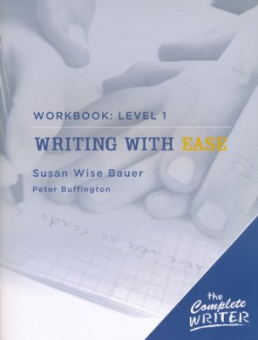
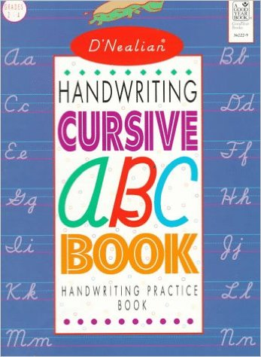

Description: This course covers simple writing samples from classic literature for children by listening to small narrations and verbally answering simple questions about these passages followed by a simple copy exercise that pertains to the sample. This course also introduces cursive handwriting exercises for 3rd grade with modified work samples for younger grades. (If your student has already committed to a different handwriting style, please inform the instructor so that accommodations can be made.)
Heather Williams is a Suzuki piano teacher and Music Together center director with a degree from Brigham Young University in Piano with over 20 years of teaching experience in private and group lessons. She has taught Writing for 4 years to homeschool students. She currently teaches piano lessons in Fair Oaks and El Dorado Hills and directs Music Together in Fair Oaks and Citrus Heights. She has 4 small children, ages 10, 8, 6 and 2 ½.
Monthly Class Fee: $18.75 (13 weeks) Total: $75

